Lab4

Task1
#include <stdio.h>

int main(){
int age;
printf("Enter your age");
scanf("%d",&age);
if(age>=18)
printf("you can vote");
else
printf("you can not vote");

}
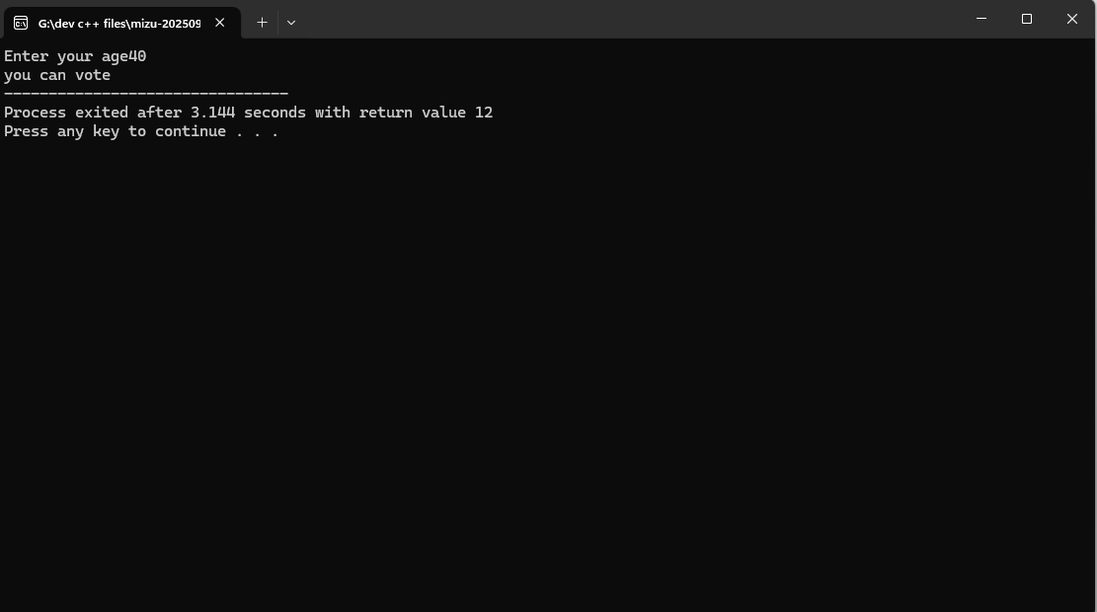

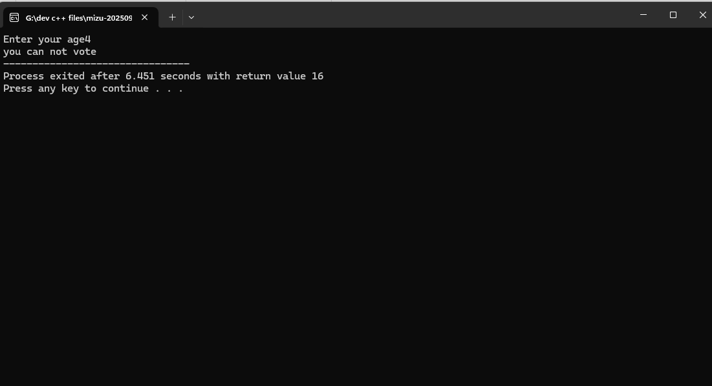

Task2
#include <stdio.h>

int main() {
int num;

printf("Enter an integer: ");
scanf("%d", &num);

if (num % 2 == 0) {
printf("%d is Even.\n", num);
} else {
printf("%d is Odd.\n", num);
}

return 0;
}

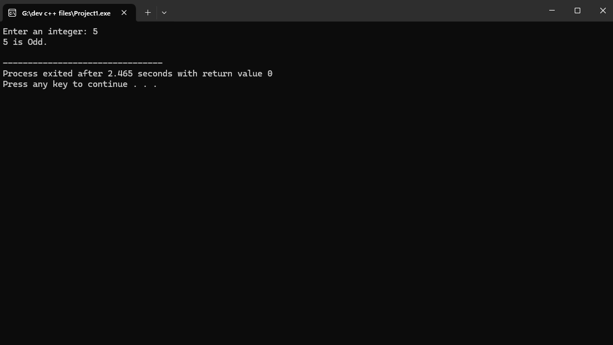
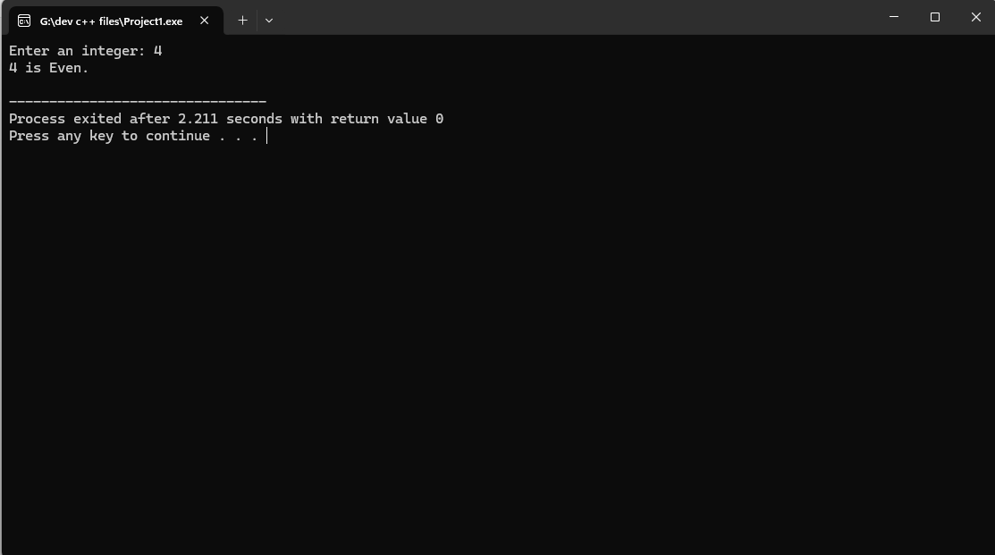

Task3
#include <stdio.h>

int main() {
int a, b, c;

printf("Enter three numbers: ");
scanf("%d %d %d", &a, &b, &c);

if (a >= b && a >= c) {
printf("%d is the largest number.\n", a);
}
else if (b >= a && b >= c) {
printf("%d is the largest number.\n", b);
}
else {
printf("%d is the largest number.\n", c);
}

return 0;
}

